Effect of chronic restraint stress on HPA axis activity and expression of BDNF and Trkb in the hippocampus of pregnant rats: possible contribution in depression during pregnancy and postpartum period.
Nader Maghsoudi¹, Rasoul Ghasemi¹, Zahra Ghaempanah², Ali M. Ardekani², Elahe Nooshinfar³
- Neuroscience Research Center, Shahid Beheshti University of Medical Sciences, Tehran, Iran
- Reproductive Biotechnology Research Center, Avicenna Research Institute, ACECR, Tehran, Iran
- Dept. of Physiology, Faculty of Paramedical Sciences, Shahid Beheshti University of Medical Sciences,
Tehran, Iran
Abstract:
BDNF its receptor TrkB in the hippocampus are targets for adverse effects of stress paradigms, in addition BDNF and its receptor play role in the pathology of brain diseases like depression. in present study we tend to evaluate the possible role of hippocampal BDNF in depression during pregnancy, to achieving this, repeated restrain stress (1 or 3 hours daily for 7 days) during the last week of pregnancy was used and alteration in the gene expression of hipocampal BDNF and TrkB was evaluated by semi-quantative PCR. The results showed that in stress group the level of ACTH and Corticosterone is increased showing that our model was efficient in inducing psychological stress, we also found that BDNF and TrkB expression are decreased in 3 hours stress group but not in 1 hour stress when compared with control group. Our results imply that decrease in BDNF and its receptor could contribute in some adverse effects of stress during pregnancy such as elevation of depressive like behavior.
Keywords: stress, BDNF, depression, ACTH, Corticosterone, semi-quantitative RT-PCR.

Introduction:
Stress-induced molecular changes may underlie perinatal and postpartum depression. Exposure to stress conditions and disturbance of physiological and psychological homeostasis induces cellular and molecular changes in the brainpans which could be a risk factor for major depression . The hippocampus expresses a high level of receptors for stress hormones and is one of the most vulnerable structures in the brain to stress conditions . Hippocampus-dependent fear memory, but not hippocampus-independent fear memory, is impaired by chronic restraint .
The hippocampus is one of the limbic structures involved in emotion and cognition. It also contributes to mood disorders like depression, and function of hippocampal formation and regulation of the HPA axis both are changed in depression . Accordingly chronic repeated stress in animals is usually linked to the depressive-like behaviors ; and repeated restraint stress during the last week of pregnancy induces depressive-like behaviors in the mothers . Incidence of depression during pregnancy and after pregnancy is elevated: 15% of women worldwide develop postpartum depression while in many mood disorders during pregnancy are also seen .
Hippocampal regulation of mood may derive directly from growth factors and trophins. BDNF (Brain-Derived Neurotrophic Factor), a member of a neurotrophin family directly involved in many physiological aspects of CNS such as neurite growth and neuronal survival , and its receptor TrkB, (tyrosine kinase receptor B) also play a key role in synaptic plasticity, learning and memory . Many stresses modulate the BDNF & TrkB expression . Expression of hippocampal BDNF is decreased in patients with depression and treatment with antidepressant drugs can enhance the expression of BDNF and TrkB .
A few studies evaluate the effect of stress during pregnancy on the physiology of the offspring , but fewer studies have been conducted on the effects of stress on the mothers; and, more importantly, the contribution of hippocampus impairment in the pathology of pregnancy and postpartum depression has been neglected. Given that chronic stress during pregnancy can induce depression-like behaviors; that hippocampus is involved in these depression-like behaviors; and that BDNF and TrkB are important to hippocampus formation and physiology, in the present study we evaluate the role of hippocampal BDNF and TrkB in depression during pregnancy and postpartum period. To conduct this study we used repeated restraint stress (1 or 3 hours daily for 7 days) during the last week of pregnancy and evaluated by semi-quantative PCR alteration in the gene expression of hippocampal BDNF and TrkB evaluated. We also evaluated the chronic stress induced HPA (Hypothalamic-Pituitary Axis) activity in pregnant rats by measuring the plasma level of ACTH and Corticosterone.

Material and Methods:
Animals:
Female albino Wistar rats weighing 200-220 g were obtained from the animal house of the Neuroscience Research Center, Shahid Beheshti University of Medical Science, Animals were maintained on a 12h light/dark cycle (light from 6am to 6pm) and kept under controlled temperature (21±1°C). Food and water were freely available through the experiment. All experiments were according to the NIH guide for the care and use of laboratory animals, and all protocols and efforts were made to minimize the number of animals used and their suffering. The animals were randomly assigned into 3 groups (5 in each): control group (without stress), 7 days of repeated 1 h stress, and 7 days of repeated 3 h stress.

Pregnancy:
For preparation of pregnant animals, female rats were weighed and then male rats (1-2 per cage) were housed for one night with them, and in the morning the males were removed. On the 14th day, based on weight gain in comparison with the first day, pregnant rats were separated from nonpregnant rats.
Groups and stress:
To induce stress during days 14–20 of pregnancy, pregnant rats were placed in Plexiglass® rod shape restrainers adaptable to animal size for 1 or 3 h/day started at 11:00. At the end of each daily stress, animals were returned to their cages, except the last day (20th), on which animals were killed.
Hormone assay:
After the last stress on the 20th day animals were anesthetized through CO₂ inhalation and decapitated. Blood samples were collected into tubes containing 5% EDTA and centrifuged at 2500 rpm for 10 min at 4° C, plasma was collected and stored at -20° C. To quantify corticosterone and ACTH levels the following commercial kits were used: for ACTH “ELISA, Phoenix Pharmaceuticals Inc., Burlingame CA, USA Intraassay CV%: 4.5 sensitivity: 0.14 ng/ml” and for corticosterone: “ELISA, DRG Instrument GMBH, Marburg, Germany, Intraassay CV%: 5 sensivity: < 1.631 nmol/L”

RNA extraction:
After decapitation hippocampi were rapidly removed and frozen in liquid nitrogen and then stored at -70°C, total RNA was extracted from 50-100 mg hippocampus according to the instructions of “RNA-BeeTM isolation of RNA” kit (QIAGEN, Inc., CA, USA). Briefly, after homogenization of the tissue in reaction mixture containing RNA-Bee and chloroform and centrifugation at 12000g for 15min at 4°C, the extracted RNA in the aqueous phase was obtained. 240 µl of this aqueous phase was mixed with the same volume of isopropanol and after centrifugation at 12000g for 10min at 4°C, RNA precipitated and formed a pellet. The pellet was washed with 75% ethanol ( by vortexing and centrifugation at 7500g for 5min at 4°C) and then ethanol was removed and the pellet of RNA was allowed to dry, then was solubilized in 25 µl DEPC water.
RNA concentration and purity were evaluated by spectrometry by optical density (OD) measurement at 260 -280 nm.
RNA transcriptase and PCR:
Approximately 1 µg of total RNA was used to generate cDNA by reverse transcription using Revert AidTM M-MuLV Reverse transcriptase, random hexamer primer and dNTP mix (all Fermentas, MD, USA) according to manufacturer’s protocol. Resultant cDNA was amplified using 10X buffer (ROCHE (state, country)), MgCl₂, taq enzyme (ROCHE) and primers specific for genes of interest. The following primers were used.
BDNF: Forward:5́́́́-AGGCACTGGAACTCGCAATG-3́́ Reverse:5́-AAGGGCCCGAACATACGATT-3́ TRKB:Forward:5́-ACAAAGGCCTTAACAAACCT-3́ Reverse:5́́́́-CCACATCAAAGGCAGGAATA3́ GAPDH: Forward:5́-AAGGTCATCCCAGAGCTGAA-3́ Reverse : 5́ ATGTAGGCCATGAGGTCCAC-3́
Electrophoresis was done on 1% agarose gel for PCR products and PCR bands were visualized using UV light and photographed. Band density was measured with AlphaEaseFC (source) software. Pixel density for each band was obtained and normalized against the endogenous control (GAPDH) of the same sample and mean ratio of each group was calculated, all data are presented as ratio of the gene of interest to GAPDH .
Data analysis:
Hormone data and Mean Ratio of each gene to GAPDH in each group were analyzed by nonparametric Mann-Whitney analysis (because the sample size was small). In all statistical comparisons, p < 0.05 was considered as significant difference.

Results:
Hormone analysis results:
To test the efficiency of our stress paradigm Hypothalamic-Pituitary-Adrenal (HPA) axis activity assessment was done and showed significant increase in ACTH both in 1 hour stress and 3 hours stress (p <0.05 for 1 hour group and <0.01 for 3 hours group, Figure 1A). As expected from ACTH results corticosterone level was also elevated in the both stress group (p <0.001, Figure 1B).
The effect of repeated restraint stress on hippocampal expression of BDNF analyzed by RT-PCR:
Comparison of normalized ratio of BDNF/GAPDH using semi-quantitative RT-PCR revealed that expression of BDNF was reduced significantly in 3 hours group stress (P= 0.003) but in the 1 hour stress group the reduction was not significant (Figs. 2A and 2B).

The effect of repeated restraint stress on hippocampal expression of TrkB analyzed by RT-PCR:
Comparison of the normalized ratio of TrkB/GAPDH for expression of TrkB revealed a similar pattern of expression for TrkB. In the 1 hour group TrkB expression was reduced but it was not quite significant (P= 0.068) in the 3 hours group TrkB was reduced significantly (P= 0.004) these results can be seen in Figures 3A and 3B.

Discussion:
In this study we evaluated two hormones in the HPA axis and the alteration in gene expression of BDNF and TrkB in response to restraint stress during pregnancy. The circulating levels of ACTH and corticosterone were elevated after 7 days of repetitive restraint stress. In addition the expression of BDNF and TrkB genes was reduced following seven days of 3 hour/day restraint stress but not following 1 hour/day stress for seven days.
Exposure to stress situations triggers responses to restore homeostasis. Stress during pregnancy has harmful effects on mothers as well as fetus biology throughout their lifetime. For example it has been reported that offspring development is influenced by gestational stress ; in addition the physiology of offspring’s adult life is also shown to be affected by gestational stress .
One of the key elements in this response is the activation of the HPA axis. Evaluation of HPA axis activity during late pregnancy is difficult because the responsiveness of this axis to central CRH is reduced in pregnancy. This reduction is due to release of CRH by placenta or other hormone fluctuations that are associated with pregnancy , This reduction can protect fetuses against the adverse effects of glucocorticoid hormones . The rat pituitary is unresponsive to placenta-derived CRH , making rats a suitable model for study of stress effects on maternal HPA axis.
In our study the activity of HPA axis was increased by seven days of either 1 hour/day or 3 hours/day restraint stress (14th to 20th day of pregnancy), as shown by elevated level of plasma ACTH and corticosterone when compared with pregnant non-stressed animals, implying that our model of repeated stress is potent enough to induce a psychological chronic stress in pregnant rats. Chronic stress has deleterious effects on the hippocampus. This area expresses high levels of both types of glucocorticoids receptors (MR and GR), and is considered as a major target for corticosterone . For instance it has been shown that extracellular level of hippocampal glutamate is increased by chronic restraint stress while adrenalectomy is able to reverse this elevation . Accordingly Yun et al. (2010) reported that chronic restraint stress severely impairs hippocampus-dependent memory . Chronic restraint stress also triggers apoptosis in hippocampal neurons , However since in our previous study we showed that 7 days of restraint stress does not induce apoptosis when applied on pregnant rats, we suggested that pregnancy may offer some protection against the adverse effects of stress .
Chronic stress appears to be a risk factor for development of psychiatric disorders both in pregnant and non-pregnant animals as it has been shown that repeated stress is associated with depression-like behaviors , a prevalent problem of pregnancy ; Daily restraint stress during pregnancy could also lead to postpartum depression-like behaviors . However Pawluski et al. (2011) did not see elevated depression-like behaviors and reasoned that this discrepancy could be due to variation in duration or type of stress . The exact mechanism for this relation is largely unknown. Some studies reported that inflammatory mediators may be involved in these stress induced depressive behaviors . Accordingly in the present study we also used daily restraint stress (1 or 3 h/day) during the last week of pregnancy as an inducer of depression-like behavior and following the last day of stress hippocampi were dissected and expression of BDNF and TrkB in these hippocampi were evaluated.
BDNF, a member of neurotrophin family of growth factors, is directly involved in neuronal growth, survival, differentiation and maintenance of physiological function of neuronal populations . Reduction in BDNF and its receptor TrkB are involved in depression, and expression of BDNF and TrkB are affected in a variety of stress situations. The majority of studies showed that BDNF expression decreases , but some have reported that TrkB decreases with stress and some others, that it increases . On the other hand hippocampus is also involved in the pathophysiology of depression as 16 patients with major depression were investigated and it was shown that hippocampus volume is decreased in depressive patients .
Based on these findings we assumed that BDNF and its receptor may be a target for adverse effects of restraint stress on hippocampus of pregnant rats, and resulting impairment of hippocampus may be involved in the stress induced increase in depression-like behaviors in the mothers. We found that 3 hours of repeated restraint stress during the last week of pregnancy cause gene expression of BDNF and TrkB to decrease, but 1 hour/day of the same stress failed to show any significant effects, in spite of the high level of ACTH and Corticosterone that was seen in 1 hour stress group. Smith et al. (1995) have suggested previously that corticosterone is not the only factor in mediating the effects of stress on BDNF expression, and that corticosterone needs a long exposure time (more than 2 hours) to affect BDNF expression . On the other hand it seems that in 1 hour/day stress the pregnancy derived protective mechanisms are still able to prevent BDNF and TrkB from being affected. As we showed previously pregnancy can protect the mother’s hippocampal neurons against stress induced apoptosis . Thus it seems that this pregnancy derived protection is also able to prevent BDNF and TrkB from being affected by stress, but the results of the present study show that this pregnancy derived protection can be overwhelmed by increment of stress duration and that expression of both BDNF and of its receptor TrkB, could be decreased.
Consistent with our results, Deng et al 2011. have reported that expression of hippocampal BDNF and TrkB is decreased in male rat models of depression , hippocampal BDNF infusion is partly able to restore the behavior deficits which could be seen in rat models of depression, these observations are consistent with the theory that BDNF deficits in the hippocampus may be involved in the pathophysiology of depression .
In summary present study showed that daily restraint stress during last week of pregnancy activates the HPA axis and elevates ACTH and corticosterone level in both 1 and 3 h/day stress group but in 1 h/day group, expression of hippocampal BDNF and TrkB was not changed significantly. It seems that a pregnancy derived protection can protect BDNF and TrkB from down-regulation but when the duration of stress was increased expression of BDNF and TrkB was reduced, as reduction in BDNF and TrkB expression and hippocampal dysfunction are involved in the pathology of depression. We concluded that reduction in BDNF and its receptor in the hippocampus of pregnant rats may contribute in the high prevalence of depression during pregnancy and postpartum period.

Acknowledgments:
This work was supported by the common grant from Neuroscience Research Center of Shahid Beheshti University (MC) and Reproductive Biotechnology Research center, Avicenna research institute (ACECR), Tehran, Iran.

References:
Aydemir, O., Deveci, A., & Taneli, F. (2005). The effect of chronic antidepressant treatment on serum brain-derived neurotrophic factor levels in depressed patients: a preliminary study. Prog Neuropsychopharmacol Biol Psychiatry, 29(2), 261-265. doi: S0278-5846(04)00251-9 [pii]
10.1016/j.pnpbp.2004.11.009 [doi]
Bremner, J. D., Narayan, M., Anderson, E. R., Staib, L. H., Miller, H. L., & Charney, D. S. (2000). Hippocampal volume reduction in major depression. Am J Psychiatry, 157(1), 115-118.
Brummelte, S., & Galea, L. A. (2010). Chronic corticosterone during pregnancy and postpartum affects maternal care, cell proliferation and depressive-like behavior in the dam. Horm Behav, 58(5), 769-779. doi: S0018-506X(10)00208-4 [pii]
10.1016/j.yhbeh.2010.07.012 [doi]
Brunton, P. J., & Russell, J. A. (2011). Allopregnanolone and suppressed hypothalamo-pituitary-adrenal axis stress responses in late pregnancy in the rat. Stress, 14(1), 6-12. doi: 10.3109/10253890.2010.482628 [doi]
De Kloet, E. R., Vreugdenhil, E., Oitzl, M. S., & Joels, M. (1998). Brain corticosteroid receptor balance in health and disease. Endocr Rev, 19(3), 269-301.
Deng, Y., Zhang, C. H., & Zhang, H. N. (2011). [Effects of chaihu shugan powder on the behavior and expressions of BDNF and TrkB in the hippocampus, amygdala, and the frontal lobe in rat model of depression]. Zhongguo Zhong Xi Yi Jie He Za Zhi, 31(10), 1373-1378.
Duman, R. S., & Monteggia, L. M. (2006). A neurotrophic model for stress-related mood disorders. Biol Psychiatry, 59(12), 1116-1127. doi: S0006-3223(06)00231-9 [pii]
10.1016/j.biopsych.2006.02.013 [doi]
Dwivedi, Y., Rizavi, H. S., Conley, R. R., Roberts, R. C., Tamminga, C. A., & Pandey, G. N. (2003). Altered gene expression of brain-derived neurotrophic factor and receptor tyrosine kinase B in postmortem brain of suicide subjects. Arch Gen Psychiatry, 60(8), 804-815. doi: 10.1001/archpsyc.60.8.804 [doi]
60/8/804 [pii]
Gotz, A. A., Wittlinger, S., & Stefanski, V. (2007). Maternal social stress during pregnancy alters immune function and immune cell numbers in adult male Long-Evans rat offspring during stressful life-events. J Neuroimmunol, 185(1-2), 95-102. doi: S0165-5728(07)00039-2 [pii]
10.1016/j.jneuroim.2007.01.019 [doi]
Jalalvand, E., Javan, M., Haeri-Rohani, A., & Ahmadiani, A. (2008). Stress- and non-stress-mediated mechanisms are involved in pain-induced apoptosis in hippocampus and dorsal lumbar spinal cord in rats. Neuroscience, 157(2), 446-452. doi: S0306-4522(08)01289-X [pii]
10.1016/j.neuroscience.2008.08.052 [doi]
Joels, M., Karst, H., Alfarez, D., Heine, V. M., Qin, Y., van Riel, E., . . . Krugers, H. J. (2004). Effects of chronic stress on structure and cell function in rat hippocampus and hypothalamus. Stress, 7(4), 221-231. doi: H7L632V754R125V0 [pii]
10.1080/10253890500070005 [doi]
Kim, J. J., & Diamond, D. M. (2002). The stressed hippocampus, synaptic plasticity and lost memories. Nat Rev Neurosci, 3(6), 453-462. doi: 10.1038/nrn849 [doi]
nrn849 [pii]
Kim, S. J., Lee, H., Joung, H. Y., Lee, G., Lee, H. J., Shin, M. K., . . . Bae, H. (2011). T-bet deficient mice exhibit resistance to stress-induced development of depression-like behaviors. J Neuroimmunol, 240-241, 45-51. doi: S0165-5728(11)00261-X [pii]
10.1016/j.jneuroim.2011.09.008 [doi]
Kimberly, W. T., Zheng, J. B., Town, T., Flavell, R. A., & Selkoe, D. J. (2005). Physiological regulation of the beta-amyloid precursor protein signaling domain by c-Jun N-terminal kinase JNK3 during neuronal differentiation. J Neurosci, 25(23), 5533-5543. doi: 25/23/5533 [pii]
10.1523/JNEUROSCI.4883-04.2005 [doi]
Leibrock, J., Lottspeich, F., Hohn, A., Hofer, M., Hengerer, B., Masiakowski, P., . . . Barde, Y. A. (1989). Molecular cloning and expression of brain-derived neurotrophic factor. Nature, 341(6238), 149-152. doi: 10.1038/341149a0 [doi]
Lowy, M. T., Gault, L., & Yamamoto, B. K. (1993). Adrenalectomy attenuates stress-induced elevations in extracellular glutamate concentrations in the hippocampus. J Neurochem, 61(5), 1957-1960.
Meltzer-Brody, S., Stuebe, A., Dole, N., Savitz, D., Rubinow, D., & Thorp, J. (2011). Elevated corticotropin releasing hormone (CRH) during pregnancy and risk of postpartum depression (PPD). J Clin Endocrinol Metab, 96(1), E40-47. doi: jc.2010-0978 [pii]
10.1210/jc.2010-0978 [doi]
Moosavi, M., Ghasemi, R., Maghsoudi, N., Rastegar, K., & Zarifkar, A. (2011). The relation between pregnancy and stress in rats: considering corticosterone level, hippocampal caspase-3 and MAPK activation. Eur J Obstet Gynecol Reprod Biol, 158(2), 199-203. doi: S0301-2115(11)00271-5 [pii]
10.1016/j.ejogrb.2011.05.005 [doi]
Nibuya, M., Morinobu, S., & Duman, R. S. (1995). Regulation of BDNF and trkB mRNA in rat brain by chronic electroconvulsive seizure and antidepressant drug treatments. J Neurosci, 15(11), 7539-7547.
Nibuya, M., Takahashi, M., Russell, D. S., & Duman, R. S. (1999). Repeated stress increases catalytic TrkB mRNA in rat hippocampus. Neurosci Lett, 267(2), 81-84. doi: S0304-3940(99)00335-3 [pii]
O'Mahony, S. M., Myint, A. M., van den Hove, D., Desbonnet, L., Steinbusch, H., & Leonard, B. E. (2006). Gestational stress leads to depressive-like behavioural and immunological changes in the rat. Neuroimmunomodulation, 13(2), 82-88. doi: 96090 [pii]
10.1159/000096090 [doi]
Pawluski, J. L., van den Hove, D. L., Rayen, I., Prickaerts, J., & Steinbusch, H. W. (2011). Stress and the pregnant female: Impact on hippocampal cell proliferation, but not affective-like behaviors. Horm Behav, 59(4), 572-580. doi: S0018-506X(11)00053-5 [pii]
10.1016/j.yhbeh.2011.02.012 [doi]
Russell, J. A., Douglas, A. J., & Brunton, P. J. (2008). Reduced hypothalamo-pituitary-adrenal axis stress responses in late pregnancy: central opioid inhibition and noradrenergic mechanisms. Ann N Y Acad Sci, 1148, 428-438. doi: NYAS1148032 [pii]
10.1196/annals.1410.032 [doi]
Saarelainen, T., Hendolin, P., Lucas, G., Koponen, E., Sairanen, M., MacDonald, E., . . . Castren, E. (2003). Activation of the TrkB neurotrophin receptor is induced by antidepressant drugs and is required for antidepressant-induced behavioral effects. J Neurosci, 23(1), 349-357. doi: 23/1/349 [pii]
Sasaki, A., Tempst, P., Liotta, A. S., Margioris, A. N., Hood, L. E., Kent, S. B., . . . Krieger, D. T. (1988). Isolation and characterization of a corticotropin-releasing hormone-like peptide from human placenta. J Clin Endocrinol Metab, 67(4), 768-773.
Shi, S. S., Shao, S. H., Yuan, B. P., Pan, F., & Li, Z. L. (2010). Acute stress and chronic stress change brain-derived neurotrophic factor (BDNF) and tyrosine kinase-coupled receptor (TrkB) expression in both young and aged rat hippocampus. Yonsei Med J, 51(5), 661-671. doi: 201009661 [pii]
10.3349/ymj.2010.51.5.661 [doi]
Smith, J. W., Seckl, J. R., Evans, A. T., Costall, B., & Smythe, J. W. (2004). Gestational stress induces post-partum depression-like behaviour and alters maternal care in rats. Psychoneuroendocrinology, 29(2), 227-244. doi: S0306453003000258 [pii]
Smith, M. A., Makino, S., Kvetnansky, R., & Post, R. M. (1995). Stress and glucocorticoids affect the expression of brain-derived neurotrophic factor and neurotrophin-3 mRNAs in the hippocampus. J Neurosci, 15(3 Pt 1), 1768-1777.
Ueyama, T., Kawai, Y., Nemoto, K., Sekimoto, M., Tone, S., & Senba, E. (1997). Immobilization stress reduced the expression of neurotrophins and their receptors in the rat brain. Neurosci Res, 28(2), 103-110. doi: S0168-0102(97)00030-8 [pii]
Vaidya, V. A., Marek, G. J., Aghajanian, G. K., & Duman, R. S. (1997). 5-HT2A receptor-mediated regulation of brain-derived neurotrophic factor mRNA in the hippocampus and the neocortex. J Neurosci, 17(8), 2785-2795.
von Bohlen und Halbach, O. (2010). Involvement of BDNF in age-dependent alterations in the hippocampus. Front Aging Neurosci, 2. doi: 10.3389/fnagi.2010.00036 [doi]
Xu, Y. L., Reinscheid, R. K., Huitron-Resendiz, S., Clark, S. D., Wang, Z., Lin, S. H., . . . Civelli, O. (2004). Neuropeptide S: a neuropeptide promoting arousal and anxiolytic-like effects. Neuron, 43(4), 487-497. doi: 10.1016/j.neuron.2004.08.005 [doi]
S0896627304004908 [pii]
Ye, Y., Wang, G., Wang, H., & Wang, X. (2011). Brain-derived neurotrophic factor (BDNF) infusion restored astrocytic plasticity in the hippocampus of a rat model of depression. Neurosci Lett, 503(1), 15-19. doi: S0304-3940(11)01144-X [pii]
10.1016/j.neulet.2011.07.055 [doi]
Yun, J., Koike, H., Ibi, D., Toth, E., Mizoguchi, H., Nitta, A., . . . Yamada, K. (2010). Chronic restraint stress impairs neurogenesis and hippocampus-dependent fear memory in mice: possible involvement of a brain-specific transcription factor Npas4. J Neurochem, 114(6), 1840-1851. doi: JNC6893 [pii]
10.1111/j.1471-4159.2010.06893.x [doi]

Figures:
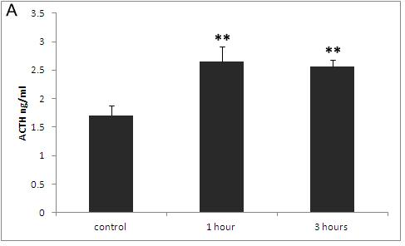
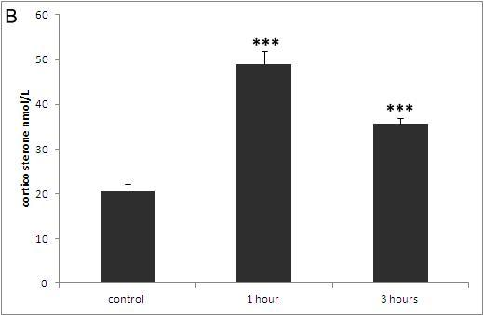
Fig. 1. The effect of restraint stress on plasma ACTH and Corticosterone levels. (A) Plasma ACTH levels after 1 and 3 h repeated stress episodes. (B) Plasma Corticosterone levels after 1 and 3 h repeated stress episode. Data are represented as mean ± SEM. ***p < 0.001, **p < 0.01 and *p < 0.05 represent the difference between control and stress groups.

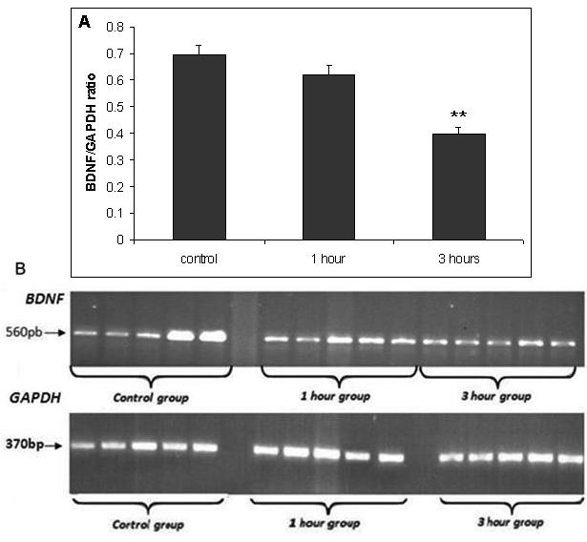
Fig. 2. Stress induced changes in expression of BDNF gene. (A) The graph shows the mean ratio of BDNF/GAPDH of three groups. (B) The band density of BDNF and GAPDH for each group can be seen. Data are represented as mean ± SEM. **p < 0.01 represent the difference between control and stress groups.
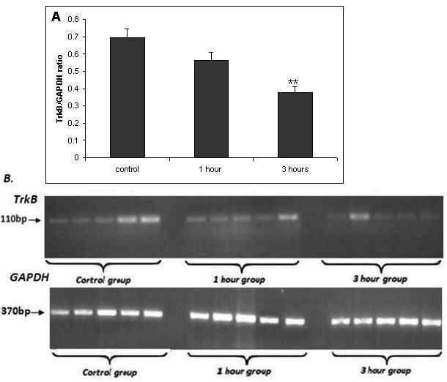Fig. 3. Stress induced changes in expression of the TrkB gene. (A) The graph shows the mean ratio of TrkB/GAPDH of three groups. (B) The band density of TrkB and GAPDH for each group can be seen. Data are represented as mean ± SEM. **p < 0.01 representing the difference between control and stress groups.

