Unusual recovery of aphasia in a polyglot Persian patient after ischemic stroke

Masoud Mehrpour MD,MPH ^{1*} , Mohammad.R Motamed MD² , Mahboubeh Aghaei MD ^{2 ,} Nazanin Jalali MD ² , Zahra Ghoreishi PhD ²

1) Department of Neurology, Firoozgar Hospital, Tehran University of Medical Sciences, Tehran, IRAN. mehrpr@tums.ac.ir Corresponding author
2)Department of Neurology, Firoozgar Hospital, Tehran University of Medical Sciences, Tehran, IRAN. mrmotamed2005@yahoo.com mahbub2006aghaei@yahoo.com nazaninejalali@gmail.com

Abstract:

Background: Aphasia is a language disorder resulting from a lesion in the cerebral. In this case report, we present a polyglot patient who recovered from aphasia at first by speaking his newly active learned language. Case report: A 69 years old male referred with acute onset right hemiparesis and global aphasia. After imaging, he treated with 75 mg r-TPA (0.9 mg/kg). After fourth day of hospitalization, he could name some objects and some short phrases but interestingly only in French language (however, his mother language was Persian).Conclusion: In our patient, recovery was first in the last learned language and his learning memory has been recovered earlier than his native languages. As in our case, we can expect to have different recovery theory that means active learning language could be the first part of recovery in aphasia. Keywords: Aphasia, Ribot,s law, Pitres Law

Introduction:

Aphasia is a language disorder resulting from a lesion in the cerebral areas of the dominant hemisphere involved in the elaboration of the expressive and sensory aspects of speech. Lesions of these areas can have a vascular (ischemic or hemorrhagic), traumatic, neoplastic or degenerative basis. In spite of the large number of people who are able to speak in one language or more other than the mother language, there are a relatively small number of articles in the available literature that discussed aphasia in bilingual or polyglot subjects (1-4).
In this case report, we present a polyglot patient who recovered from aphasia at first by speaking his newly active learned language.

Case report:

A 69 years old male patient was referred to our stroke center, Firoozgar hospital affiliated to Tehran University of Medical Sciences, with acute onset right hemiparesis and global aphasia. He was arrived to emergency department one hour after onset of symptoms. NIHSS was about 18. Brain CT-scan showed mild sulcus effacement in left frontoprital lobes (image 1). He had no contraindication for thrombolytic therapy. Therefore, he treated with 75 mg r-TPA (0.9 mg/kg) with monitoring of vital signs and checking of any exacerbation in his symptoms. After 24 hours, control brain CT scan showed ischemic stroke in territory of left middle cerebral artery with hemorrhagic transformation (asymptomatic ICH due to thrombolytic therapy) (image 2). Hemiparesis of patient got better during next week and comprehension of patient got better, he could understood and obey gradually. After fourth day of hospitalization he could name some objects and some short phrases but interestingly only in French language. He could not speak in his mother tongue or his current language. He was a polyglot patient who has spoken Persian and Turkish since childhood. He learned German when he was 32 years old and had been living in Germany for more than 10 years. He has started to learn French since one year ago. One week later, his language test had shown that recovery of French language with no recovery of other languages. His muscle force was about 4/5. He was discharged from hospital and one month later his language tests showed the parallel recovery of Turkish and Persian language and he had only anomic aphasia in these two languages.

Conclusion:

Analysis of recovery patterns following aphasia in polyglots may contribute to our understanding of brain-language relationships. Many polyglots with acquired aphasia recover each of their languages in proportion to their premorbid fluency in the language . Some, however, did not meet. For those cases in which differential recovery patterns have been observed, we may ask which language returns first, and why.
Ribot (5) supposed that the over learning of items learned early in life rendered these items less susceptible to loss following brain damage and more likely to return first, should such loss occur. The rule of Ribot (5), then, for polyglot aphasics, is that the first learned language returns first. Pitres (6) noted that Ribot’s (5) rule did not always hold. He proposed that the language most in use during the period immediately prior to the onset of aphasia was the one that returned first.
Krapf (7) observed that often neither “rule” applied, nor they championed a theory of affect. They argued that the social and/or affective environment prior to or following cerebral injury determined which language returned first. Other arguments have also been proposed, and Paradis(8) categorizes them into (1) appropriateness of the language to the situation, (2) severity of the lesion, and (3) differential reading knowledge of the languages (e.g. classical Greek). Paradis also identified six recovery patterns of aphasia in polyglot patients: 1) Parallel recovery occurs when both languages are impaired and restored at the same rate. 2) Differential recovery occurs when languages recover differentially relative to their premorbid levels. 3) Selective recovery occurs when one language is not recovered. In blended recovery, patients inappropriately mix their languages. Nearly 30% of the cases show a selective pattern of recovery (the patient did not regain one or more of his languages).
Pitres (6) reported 2 patients. One patient of recovered French and Spanish, but lost the ability even to comprehend Italian. Another patient regained some of his proficiency in French but not in German, English, Spanish or Arabic, all of which he spoke fluently before the injury.
4) Antagonistic type of recovery pattern. One language recovers to a certain extent first and it starts regressing when the other language begins to recover. The antagonistic pattern of recovery is seen to be the least common. By contrast, in selective aphasia, there is aphasia in one language without impairment evident in the other.
5) Rates of recovery vary. Two languages may eventually recover but recovery of the second language may only begin after the first has recovered, which is called successive recovery of one language after the other.
6) Less often, there are mixed patterns or mutual interference between the languages seen in the process of recovery.
In our patient there is a pattern of recovery that may be near to pitres low. Altough his first language whom could speak was neither his current language nor his mother tongue. He had recovery of newly active learned language at first and then the three first learned languages recovered parallel.
Does the age (early or late) of acquiring a language affect the areas of cortex activated whilst using that language, is a matter of debate. The representation of grammatical aspects of languages seems to be different between the two languages if second language is acquired after the age of 7, with automatic processes and correctness being lower than those of the native language (5).
In our patient, recovery was first in the last learned language and his learning memory has been recovered earlier than his native languages. (Turkish and Persian) this may be compatible with the hypothesis of Krapf (7).
As in our case we can expect to have different recovery theory that means active learning language could be the first part of recovery in aphasia.
Fig 1- Brain Ct-scan at admission and after 24 hours
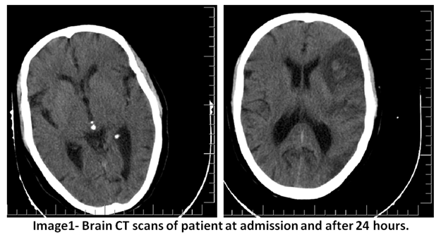

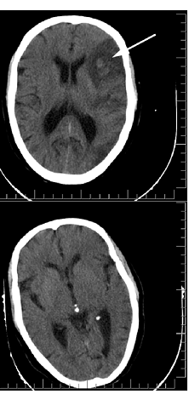
Fig 2- Control Ct-Scan (ischemic stroke in territory of left middle cerebral artery with hemorrhagic transformation)

References:

1. Tschirren M, Laganaro M, Michel P, Martory MD, Di Pietro M, Abutalebi J, et al. Language and syntactic impairment following stroke in late bilingual aphasics. Brain Lang. 2011 Dec;119(3):238-42.
2. Green DW, Ruffle L, Grogan A, Ali N, Ramsden S, Schofield T, et al. Parallel recovery in a trilingual speaker: the use of the Bilingual Aphasia Test as a diagnostic complement to the Comprehensive Aphasia Test. Clin Linguist Phon. 2011 Jun;25(6-7):449-512.
3. Green DW, Grogan A, Crinion J, Ali N, Sutton C, Price CJ. Language control and parallel recovery of language in individuals with aphasia. Aphasiology. 2010 Feb;24(2):188-209.
4. Meinzer M, Obleser J, Flaisch T, Eulitz C, Rockstroh B. Recovery from aphasia as a function of language therapy in an early bilingual patient demonstrated by fMRI. Neuropsychologia. 2007 Mar 25;45(6):1247-56.
5. Pearce JM. A note on aphasia in bilingual patients: Pitres' and Ribot's laws. Eur Neurol. 2005;54(3):127-31.
6. Lorch M. Bilingualism and memory: early 19th century ideas about the significance of polyglot aphasia. Cortex. 2007 Jul;43(5):658-66.
7. Krapf EE. [Not Available]. Encephale. 1957;46(5-6):623-9.
8. Paradis M. Principles underlying the Bilingual Aphasia Test (BAT) and its uses. Clin Linguist Phon. 2011 Jun;25(6-7):427-43.

